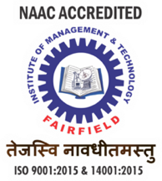 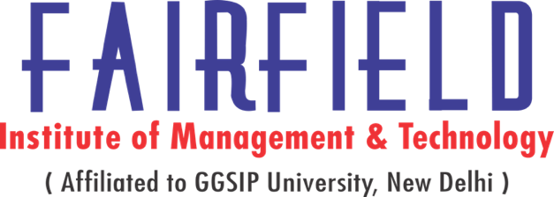 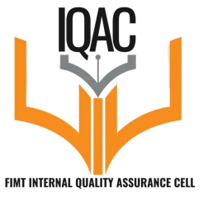



**CIRCULAR**

FIMT Training & Placement Cell is a conducting a seminar on 11.03.2022 (Friday) on video resume under the Internal Quality Assurance Cell ( lQAC).

This seminar is going for the benefit of all the students of(B.Ed, B.Com, BCA, BBA, BA-JMC, BA(H) Eco, BA(H) ENG) 4th & 6th semester.

Topic: Video Resume

Seminar Day & Date : Friday & 11.03.2022

Seminar Timings: 1:00pm to 2:00 pm

Seminar Venue:Wing 'A' Auditorium

Seminar Incharge: Dr. Suman Rao, Associate Professor, FIMT

