BBA 6th semester
BBA 302: Business Policy & Strategy
Unit I lectures:-14
Introduction: Nature, scope and importance of the course on Business Policy; Evolution of this
course – Forecasting, Long-range planning, strategic planning and strategic management.
Strategic Management Process: Formulation Phase – vision, mission, environmental scanning,
objectives and strategy; implementation phase – Strategic Activities, Evaluation and Control.
Unit II lectures:-10
Environmental Analysis: Need, Characteristics and categorization of environmental factors;
approaches to the environmental scanning process – structural analysis of competitive
environment; ETOP a diagnosis tool.
Unit III lectures:-10
Analysis of Internal Resources: Strengths and Weakness; Resource Audit; Strategic Advantage
Analysis; Value-Chain Approach to Internal Analysis; Methods of analysis and diagnosing
Corporate Capabilities – Functional Area Profile and Resource Deployment Matrix, Strategic
Advantage Profile; SWOT analysis.
Unit IV lectures:-14
Formulation of Strategy: Approaches to Strategy formation; major strategy options – Stability,
Growth and Expansion, Diversification, Retrenchment, Mixed Strategy; Choice of Strategy –
BCG Model; Stop-Light Strategy Model; Directional Policy Matrix (DPM) Model,
Product/Market Evolution – Matrix and Profit Impact of Market Strategy (PIMS) Model;
Major Issues involved in the Implementation of strategy: Organization structure; leadership
and resource allocation.

Unit-1

NATURE OF BUSINESS POLICY:

Definition of Business Policy: business policy may be defined as:

“Business policy is the study of the roles and responsibilities of top level management, the significant issues affecting organizational success and the decisions affecting organization in long-run.”

Business policies are the guidelines developed by an organization to govern its actions. They define the limits within which decisions must be made. Business policy also deals with acquisition of resources with which organizational goals can be achieved. Business policy is the study of the roles and responsibilities of top level management, the significant issues affecting organizational success and the decisions affecting organization in long-run.

Features of Business Policy:
An effective business policy must hav An effective business policy must have following features-
- Specific- Policy should be specific/definite. If it is uncertain, then the implementation will become difficult.
- Clear- Policy must be unambiguous. It should avoid use of jargons and connotations. There should be no misunderstandings in following the policy.
- Reliable/Uniform- Policy must be uniform enough so that it can be efficiently followed by the subordinates.
- Appropriate- Policy should be appropriate to the present organizational goal.
- Simple- A policy should be simple and easily understood by all in the organization.
- Inclusive/Comprehensive- In order to have a wide scope, a policy must be comprehensive.
- Flexible- Policy should be flexible in operation/application. This does not imply that a policy should be altered always, but it should be wide in scope so as to ensure that the line managers use them in repetitive/routine scenarios.
- Stable- Policy should be stable else it will lead to indecisiveness and uncertainty in minds of those who look into it for guidance.

Difference between Policy and Strategy
The term “policy” should not be considered as synonymous to the term “strategy”. The difference between policy and strategy can be summarized as follows-
1. Policy is a blueprint of the organizational activities which are repetitive/routine in nature. While strategy is concerned with those organizational decisions which have not been dealt/faced before in same form.
2. Policy formulation is responsibility of top level management. While strategy formulation is basically done by middle level management.
3. Policy deals with routine/daily activities essential for effective and efficient running of an organization. While strategy deals with strategic decisions.
4. Policy is concerned with both thought and actions. While strategy is concerned mostly with action.
5.A policy is what is, or what is not done. While a strategy is the methodology used to achieve a target as prescribed by a policy.

Scope of Business Policy
A business policy is: guidelines that facilitate to reach a predetermined objective both in mode and manner formulated from the top to the lower level management while Objectives are the endpoints to a plan. The nature and objective of business policy are both formulated as plans and determined by a business organization. Once established the policy decisions shape the future of a company channel the available resources along desired lines and direct the energies of people working at various levels toward predetermined goals. In a way, business policy implies the choice of purposes, the shaping of organizational identity and character the continuous definition of what is to be achieved and the deployment of resources for achieving corporate goals.

Parameters of Policy

There are certain parameters for business policy, they are:

1. Policy should be identifiable and clear, either in words or in practice.
2. Objectives of the policy should be fully identified and well defined.
3. Policy should not be conflicting with other functional and divisional policies of the company.
4. The policy should be capable enough to fully exploit the opportunities.
5. Policy should be characterized by fairness and honesty with organizational philosophy, objectives, goals and strategy.
6. Policy should be appropriate to the desired level of contribution to society.
7. Policy should be acceptable to all concerned; i.e., it should be appropriate to the personal values and aspirations of the key managers.
8. Policy should constitute a clear stimulus to organizational effort and commitment.
9. Policy should always be realistic.

Importance of Business Policy

A written business policy communicates your company's expectations about appropriate employee work performance. Policy illustrates the acceptable performance boundaries while simultaneously addressing the employees' needs. Some employers prefer a written policy that covers every conceivable situation; others prefer no written policy, whereby management decides each case as the situation merits. Find the ideal balance when creating a business policy for your business.

Balance
The ideal business policy encourages individual productivity without making the employee feel as though you micromanage him. According to Entrepreneur magazine, neither an extremely detailed nor a nonexistent business policy create a highly productive work environment. Put your business expectations in writing, so employees know how to meet your requirements. Address employee goals, and tell him how you expect him to achieve the goals. Once communicated, faithfully enforce, manage and update your business policies.

Job Descriptions
Include in your business policy a description of each position in the organization. Employees must understand their role and how they will interact with others within the organization. Each employee should understand how their work impacts others in the company. Make the reporting structures clear both inside the department, between departments and company wide. Once employees understand their responsibilities, hold them responsible for their work performance. The AME Info website describes business policies as "the strategic link between the company's vision and its day-to-day operations." A well-written business policy allows for management guidance in business operations without constant intervention by management.

Liability
All employees, including managers, must understand the acceptable behavior boundaries at work. Entrepreneur magazine states that when employees misbehave on the job, the employer may be held liable for how that situation affects clients, individuals or other employees. A written business policy with clear behavioral expectations helps establish that you do not approval of and are not contributing to the employee's bad behavior. The lack of a written business policy can lead to litigation.

Consequences for Violations
Establish rules that address any violations of your business policy. Stating the consequences for violating business policy puts the employee on notice and also increases the employer's options for effectively dealing with behaviors contrary to policy. Decide what behaviors mandate an immediate dismissal and what behaviors will trigger a disciplinary approach, and clearly outline the steps involved in your disciplinary procedure. From policy, the employee understands the disciplinary process. When possible, improve the employee's future performance and the company's employee retention rate by helping the employee strengthen a flawed performance, rather than losing him as a valued member of your team.

Classification of Policies:

A number of policies are used in an enterprise in order to attain the organizational objectives. Policies may be classified as follows:
(A) On the Basis of Source

According to their source, origin or emergence, policies may be of the following kinds:
1. Originated Policy

It is also known as formulated policy. It is a policy deliberately formulated by top management to guide decision-making at lower levels, board of directors, the chief executive, the executive committee of the board or heads of the major departments or divisions. Such policies are broad in scope and affect usually the whole organisation or its major segments. These policies are often written ones, typically in the form of a policy manual of the organisation and flow down.

2. Appealed Policy
It is a policy formulated on the appeal or request of subordinates for filling the gaps left by originated policies. In other words, when a subordinates refers an exceptional problem of recurring nature not covered by existing policies, to his superior and appeals for a policy decision. When the superior makes decision in such a case, it becomes a precedent (policy) for future action. Such policies may be formulated at any level and are in the nature of flowing upward policies.

3.Imposed policy
It is a policy, which an organisation is compelled to adopt due to some outside forces, such as the government and its regulatory agencies, trade association, trade unions.

(B) On the Basis of Functions.

Policies are needed in all areas of business of an enterprise. These may be classified on the basis of different managerial functions as follows:

1.Production Policy
Raw material, purchase policy, repairs and maintenance policy, technology adoption and development policy, quality control policy, inventory policy and research and development policy are some examples in the category. Indent for the purchase of raw materials should be made at least a week in advance is an example of Raw Materials Purchase Policy.

2. Human Resource Policy
Examples in this category are recruitment policy, training policy, employee career development policy, wages and salary policy, placement policy, promotion policy and transfer policy, employee participation policy. Any vacancy shall be filled first by promotion from within the organisation and then, if need be, from outside sources Is an example of Recruitment Policy.

3. Marketing Policy
Capital structure policy, packaging policy, distribution policy, advertising policy, customer service policy, credit policy, market research policy and important examples in this category. Customer’s complaint must be responded within the next day is an example of Customer Service Policy.

4. Finance Policy
Capital structure policy, fixed capital policy, working capital policy, investment policy, research policy, dividend policy are some examples in this category. Excess capital, if any should be invested for short term only, preferably in limited company shares registered in stock exchange is an example of Investment Policy.

5. Accounting Policy
Inventory valuation policy, depreciation policy, provisions policy (for bad debts etc) deferred revenue expenditure policy etc. are examples in this category. Deferred revenue expenditure (e.g., a huge amount spent on advertisment) should be spread over the years of its benefit generation and written off every year accordingly, is an example of Deferred revenue expenditure policy.

FORECASTING :

Planning tool that helps management in its attempts to cope with the uncertainty of the future, relying mainly on data from the past and present and analysis of trends. Forecasting starts with certain assumptions based on the management's experience, knowledge, and judgment.

Forecasting is the process of making predictions of the future based on past and present data and most commonly by analysis of trends. A commonplace example might be estimation of some variable of interest at some specified future date. Prediction is a similar, but more general term. Both might refer to formal statistical methods employing time series, cross-sectional or longitudinal data, or alternatively to less formal judgmental methods. Usage can differ between areas of application: for example, in hydrology the terms "forecast" and "forecasting" are sometimes reserved for estimates of values at certain specific future times, while the term "prediction" is used for more general estimates, such as the number of times floods will occur over a long period.

Features of Forecasting:
Peculiarities, characteristics or features of forecasting are as follows:-
1.Forecasting in concerned with future events.
2.It shows the probability of happening of future events.
3.It analysis past and present data.
4.It uses statistical tools and techniques.
5.It uses personal observations

Steps in Forecasting:

Procedure, stages or general steps involved in forecasting are given below:-
1.Analysing and understanding the problem : The manager must first identify the real problem for which the forecast is to be made. This will help the manager to fix the scope of forecasting.
2.Developing sound foundation : The management can develop a sound foundation, for the future after considering available information, experience, type of business, and the rate of development.
3.Collecting and analyzing data : Data collection is time consuming. Only relevant data must be kept. Many statistical tools can be used to analyze the data.
4.Estimating future events : The future events are estimated by using trend analysis. Trend analysis makes provision for some errors.
5.Comparing results : The actual results are compared with the estimated results. If the actual results tally with the estimated results, there is nothing to worry. In case of any major difference between the actuals and the estimates, it is necessary to find out the reasons for poor performance.
6.Follow up action : The forecasting process can be continuously improved and refined on the basis of past experience. Areas of weaknesses can be improved for the future forecasting. There must be regular feedback on past forecasting.
Importance of Forecasting:

Merits, significance or importance of forecasting involves following points:-
1.Forecasting provides relevant and reliable information about the past and present events and the likely future events. This is necessary for sound planning.
2.It gives confidence to the managers for making important decisions.
3.It is the basis for making planning premises.
4.It keeps managers active and alert to face the challenges of future events and the changes in the environment.

Limitations of Forecasting:

Demerits, criticism or limitations of forecasting involves following points:-
1.The collection and analysis of data about the past, present and future involves a lot of time and money. Therefore, managers have to balance the cost of forecasting with its benefits. Many small firms don't do forecasting because of the high cost.
2.Forecasting requires proper judgement and skills on the part of managers. Forecasts may go wrong due to bad judgement and skills on the part of some of the managers. Therefore, forecasts are subject to human error.
3.Forecasting can only estimate the future events. It cannot guarantee that these events will take place in the future. Long-term forecasts will be less accurate as compared to short-term forecast.
Methods of forecasting:

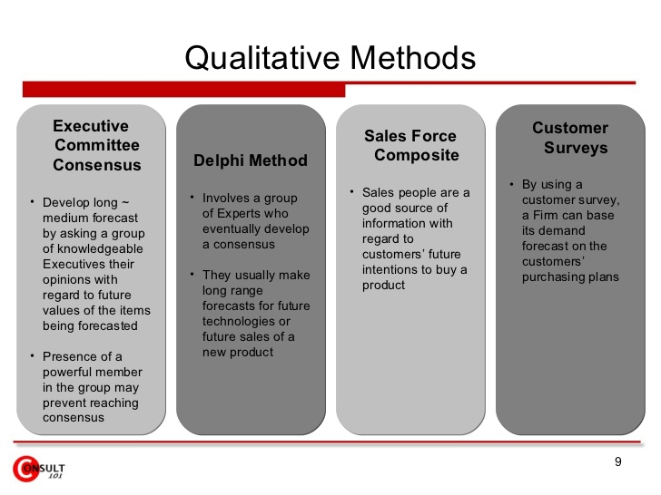
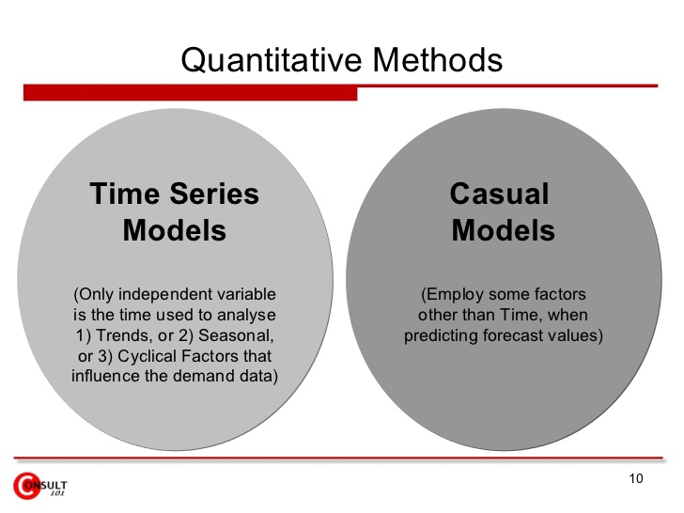

Long Range Planning:

Long-range, or strategic, planning is a way to identify what you want in the future and how you are going to get there. Whether you are looking at school buildings or curriculum, the components of the planning process are the same.

Strategy - Definition and Features
The word “strategy” is derived from the Greek word “stratçgos”; stratus (meaning army) and “ago” (meaning leading/moving).
Strategy is an action that managers take to attain one or more of the organization’s goals. Strategy can also be defined as “A general direction set for the company and its various components to achieve a desired state in the future. Strategy results from the detailed strategic planning process”.
A strategy is all about integrating organizational activities and utilizing and allocating the scarce resources within the organizational environment so as to meet the present objectives. While planning a strategy it is essential to consider that decisions are not taken in a vaccum and that any act taken by a firm is likely to be met by a reaction from those affected, competitors, customers, employees or suppliers.
Strategy can also be defined as knowledge of the goals, the uncertainty of events and the need to take into consideration the likely or actual behavior of others. Strategy is the blueprint of decisions in an organization that shows its objectives and goals, reduces the key policies, and plans for achieving these goals, and defines the business the company is to carry on, the type of economic and human organization it wants to be, and the contribution it plans to make to its shareholders, customers and society at large.

Features of Strategy
- Strategy is Significant because it is not possible to foresee the future. Without a perfect foresight, the firms must be ready to deal with the uncertain events which constitute the business environment.
- Strategy deals with long term developments rather than routine operations, i.e. it deals with probability of innovations or new products, new methods of productions, or new markets to be developed in future.

STARTEGIC PLANNING & STRATEGIC MANAGEMENT
Strategic planning is defined as an organization's process of defining its strategy, or direction,and making decisions on allocating its resources to pursue this strategy. In order to determine the direction of the organization, it is necessary to understand its current position and the possible avenues through which it can pursue a particular course of action. Generally, strategic planning
deals with at least one of three key questions:
1. "What do we do?"
2. "For whom do we do it?"
3. "How do we excel?"

In many organizations, this is viewed as a process for determining where an organization is going over the next year or—more typically—3 to 5 years (long term), although some extend their vision to 20 years
.
Key components
The key components of 'strategic planning' include an understanding of the firm's vision,
mission, values and strategies. The vision and mission are often captured in a Vision Statement and Mission Statement.
Vision: outlines what the organization wants to be, or how it wants the world in which it operates to be (an "idealized" view of the world). It is a long-term view and concentrates on working with the poor might have a vision statement which reads "A World without Poverty."
Mission: Defines the fundamental purpose of an organization or an enterprise, succinctly describing why it exists and what it does to achieve its vision. For example, the charity above might have a mission statement as "providing jobs for the homeless and unemployed".
Values: Beliefs that are shared among the stakeholders of an organization. Values drive an organization's culture and priorities and provide a framework in which decisions are made. For example, "Knowledge and skills are the keys to success" or "give a man bread and feed him for a day, but teach him to farm and feed him for life". These example values may set the priorities of self sufficiency over shelter.
Strategy: Strategy, narrowly defined, means "the art of the general." A combination of
the ends (goals) for which the firm is striving and the means (policies) by which it is seeking to get there. A strategy is sometimes called a roadmap which is the path chosen to plow towards the end vision. The most important part of implementing the strategy is ensuring the company is going in the right direction which is towards the end vision.
Organizations sometimes summarize goals and objectives into a mission statement and/or a vision statement. Others begin with a vision and mission and use them to formulate goals and objectives. Many people mistake the vision statement for the mission statement, and sometimes one is simply used as a longer term version of the other

Strategic management

Strategic Management is all about identification and description of the strategies that managers can carry so as to achieve better performance and a competitive advantage for their organization. An organization is said to have competitive advantage if its profitability is higher than the average profitability for all companies in its industry.
Strategic management can also be defined as a bundle of decisions and acts which a manager undertakes and which decides the result of the firm’s performance. The manager must have a thorough knowledge and analysis of the general and competitive organizational environment so as to take right decisions. They should conduct a SWOT Analysis (Strengths, Weaknesses, Opportunities, and Threats), i.e., they should make best possible utilization of strengths, minimize the organizational weaknesses, make use of arising opportunities from the business environment and shouldn’t ignore the threats.
Strategic management is nothing but planning for both predictable as well as unfeasible contingencies. It is applicable to both small as well as large organizations as even the smallest organization face competition and, by formulating and implementing appropriate strategies, they can attain sustainable competitive advantage.
It is a way in which strategists set the objectives and proceed about attaining them. It deals with making and implementing decisions about future direction of an organization. It helps us to identify the direction in which an organization is moving.
Strategic management is a continuous process that evaluates and controls the business and the industries in which an organization is involved; evaluates its competitors and sets goals and strategies to meet all existing and potential competitors; and then reevaluates strategies on a regular basis to determine how it has been implemented and whether it was successful or does it needs replacement.
Strategic Management gives a broader perspective to the employees of an organization and they can better understand how their job fits into the entire organizational plan and how it is co-related to other organizational members. It is nothing but the art of managing employees in a manner which maximizes the ability of achieving business objectives. The employees become more trustworthy, more committed and more satisfied as they can co-relate themselves very well with each organizational task. They can understand the reaction of environmental changes on the organization and the probable response of the organization with the help of strategic management. Thus the employees can judge the impact of such changes on their own job and can effectively face the changes. The managers and employees must do appropriate things in appropriate manner. They need to be both effective as well as efficient.
One of the major role of strategic management is to incorporate various functional areas of the organization completely, as well as, to ensure these functional areas harmonize and get together well. Another role of strategic management is to keep a continuous eye on the goals and objectives of the organization.

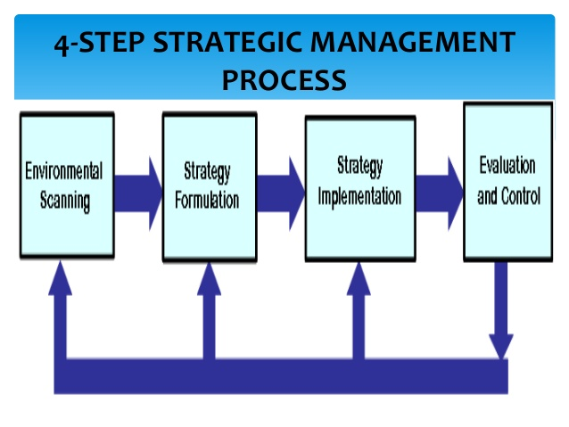
Goal-Setting
The purpose of goal-setting is to clarify the vision for your business. This stage consists of identifying three key facets: First, define both short- and long-term objectives. Second, identify the process of how to accomplish your objective. Finally, customize the process for your staff, give each person a task with which he can succeed. Keep in mind during this process your goals to be detailed, realistic and match the values of your vision. Typically, the final step in this stage is to write a mission statement that succinctly communicates your goals to both your shareholders and your staff.
Analysis
Analysis is a key stage because the information gained in this stage will shape the next two stages. In this stage, gather as much information and data relevant to accomplishing your vision. The focus of the analysis should be on understanding the needs of the business as a sustainable entity, its strategic direction and identifying initiatives that will help your business grow. Examine any external or internal issues that can affect your goals and objectives. Make sure to identify both the strengths and weaknesses of your organization as well as any threats and opportunities that may arise along the path.
Strategy Formulation
The first step in forming a strategy is to review the information gleaned from completing the analysis. Determine what resources the business currently has that can help reach the defined goals and objectives. Identify any areas of which the business must seek external resources. The issues facing the company should be prioritized by their importance to your success. Once prioritized, begin formulating the strategy. Because business and economic situations are fluid, it is critical in this stage to develop alternative approaches that target each step of the plan.
Strategy Implementation
Successful strategy implementation is critical to the success of the business venture. This is the action stage of the strategic management process. If the overall strategy does not work with the business' current structure, a new structure should be installed at the beginning of this stage. Everyone within the organization must be made clear of their responsibilities and duties, and how that fits in with the overall goal. Additionally, any resources or funding for the venture must be secured at this point. Once the funding is in place and the employees are ready, execute the plan.
Evaluation and Control
Strategy evaluation and control actions include performance measurements, consistent review of internal and external issues and making corrective actions when necessary. Any successful evaluation of the strategy begins with defining the parameters to be measured. These parameters should mirror the goals set in Stage 1. Determine your progress by measuring the actual results versus the plan. Monitoring internal and external issues will also enable you to react to any substantial change in your business environment. If you determine that the strategy is not moving the company toward its goal, take corrective actions. If those actions are not successful, then repeat the strategic management process. Because internal and external issues are constantly evolving, any data gained in this stage should be retained to help with any future strategies.

Importance Of Strategic Management process:
- It provides a way to anticipate future problems and opportunities.
- It provides employees with clear objectives and directions for the future of the organization.
- It results in more effective and better performance compared to non-strategic management organizations.
- It increases employee satisfaction and motivation.
- It results in faster and better decision making and
- It results on cost savings.
Moreover, Greenley stresses that strategic management offers the following process and personal benefits:
- It allows for identification, prioritization, and exploitation of opportunities.
- It provides an objective view of management problems.
- It represents a framework for improved coordination and control of activities.
- It minimizes the effects of adverse conditions and changes.
- It allows major decisions to better support established objectives.
- It allows more effective allocation of time and resources to identified opportunities.
- It allows fewer resources and less time to be devoted to correcting erroneous or ad hoc decisions.
- It creates a framework for internal communication among personnel.
- It helps to integrate the behavior of individuals into a total effort.
- It provides a basic for the clarification of individual responsibilities.
- It gives encouragement to forward thinking.
- It provides a cooperative, integrated, and enthusiastic approach to tackling problems and opportunities.
- It encourages a favorable attitude towards change.
- It gives a degree of discipline and formality to the management of a business.
The Strategic Planning Process

In today's highly competitive business environment, budget-oriented planning or forecast-based planning methods are insufficient for a large corporation to survive and prosper. The firm must engage in strategic planning that clearly defines objectives and assesses both the internal and external situation to formulate strategy, implement the strategy, evaluate the progress, and make adjustments as necessary to stay on track.
A simplified view of the strategic planning process is shown by the following diagram:

The Strategic Planning Process
Mission &
Objectives


Environmental
Scanning

Strategy
Formulation

Strategy
Implementation

Evaluation
& Control

Mission and Objectives
The mission statement describes the company's business vision, including the unchanging values and purpose of the firm and forward-looking visionary goals that guide the pursuit of future opportunities.
Guided by the business vision, the firm's leaders can define measurable financial and strategic objectives. Financial objectives involve measures such as sales targets and earnings growth. Strategic objectives are related to the firm's business position, and may include measures such as market share and reputation.

Environmental Scan
The environmental scan includes the following components:
- Internal analysis of the firm
- Analysis of the firm's industry (task environment)
- External macroenvironment (PEST analysis)
The internal analysis can identify the firm's strengths and weaknesses and the external analysis reveals opportunities and threats. A profile of the strengths, weaknesses, opportunities, and threats is generated by means of a SWOT analysis
An industry analysis can be performed using a framework developed by Michael Porter known as Porter's five forces. This framework evaluates entry barriers, suppliers, customers, substitute products, and industry rivalry.

Strategy Formulation
Given the information from the environmental scan, the firm should match its strengths to the opportunities that it has identified, while addressing its weaknesses and external threats.
To attain superior profitability, the firm seeks to develop a competitive advantage over its rivals. A competitive advantage can be based on cost or differentiation. Michael Porter identified three industry-independent generic strategies from which the firm can choose.

Strategy Implementation
The selected strategy is implemented by means of programs, budgets, and procedures. Implementation involves organization of the firm's resources and motivation of the staff to achieve objectives.
The way in which the strategy is implemented can have a significant impact on whether it will be successful. In a large company, those who implement the strategy likely will be different people from those who formulated it. For this reason, care must be taken to communicate the strategy and the reasoning behind it. Otherwise, the implementation might not succeed if the strategy is misunderstood or if lower-level managers resist its implementation because they do not understand why the particular strategy was selected.

Evaluation & Control
The implementation of the strategy must be monitored and adjustments made as needed.
Evaluation and control consists of the following steps:
- Define parameters to be measured
- Define target values for those parameters
- Perform measurements
- Compare measured results to the pre-defined standard
- Make necessary changes

Top of Form
Bottom of Form

STRATEGIC MANAGEMENT PROCESS - MEANING, STEPS AND COMPONENTS
The strategic management process means defining the organization’s strategy. It is also defined as the process by which managers make a choice of a set of strategies for the organization that will enable it to achieve better performance. Strategic management is a continuous process that appraises the business and industries in which the organization is involved; appraises it’s competitors; and fixes goals to meet all the present and future competitor’s and then reassesses each strategy.

ENVIRONMENTAL SCANNING - INTERNAL & EXTERNAL ANALYSIS OF ENVIRONMENT
Organizational environment consists of both external and internal factors. Environment must be organizational success. Environmental scanning refers to possession and utilization of information about occasions, patterns, trends, and relationships within an organization’s internal and external environment. It helps the managers to decide the future path of the organization. Scanning must identify the threats and opportunities existing in the environment.
While strategy formulation, an organization must take advantage of the opportunities and minimize the threats. A threat for one organization may be an opportunity for another.
Internal analysis of the environment is the first step of environment scanning. Organizations should observe the internal organizational environment. This includes employee interaction with other employees, employee interaction with management, manager interaction with other managers, and management interaction with shareholders, access to natural resources,brand awareness, organizational structure, main staff, operational potential, etc.
Examining the industry environment needs an appraisal of the competitive structure of the organization’s industry, including the competitive position of a particular organization and its main rivals. Also, an assessment of the nature, stage, dynamics and history of the industry is essential. It also implies evaluating the effect of globalization on competition within the industry.
Analyzing the national environment needs an appraisal of whether the national framework helps in achieving competitive advantage in the globalized environment.
Analysis of macro environment
includes exploring macro-economic, social, government, legal, technological and international factors that may influence the environment. The analysis of organization’s external environment reveals opportunities and threats for an organization. Strategic managers must not only recognize the present state of the environment and their industry but also be able to predict its future positions.

STEPS IN STRATEGY FORMULATION PROCESS
Strategy formulation refers to the process of choosing the most appropriate course of action for the realization of organizational goals and objectives and thereby achieving the organizational vision. The process of strategy formulation basically involves six main steps. Though these steps do not follow a rigid chronological order, however they are very rational and can be easily followed in this order.
1. Setting Organizations’ objectives - The key component of any strategy statement is to set the long-term objectives of the organization. It is known that strategy is generally a medium for realization of organizational objectives. Objectives stress the state of being there whereas Strategy stresses upon the process of reaching there. Strategy includes both the fixation of objectives as well the medium to be used to realize those objectives. Thus,strategy is a wider term which believes in the manner of deployment of resources so as to achieve the objectives.
2. Evaluating the Organizational Environment - The next step is to evaluate the general economic and industrial environment in which the organization operates. This includes a review of the organizations competitive position. It is essential to conduct a qualitative and quantitative review of an organizations existing product line. The purpose of such a review is to make sure that the factors important for competitive success in the market can be discovered so that the management can identify their own strengths and weaknesses as well as their competitors’ strengths and weaknesses. After identifying its strengths and weaknesses, an organization must keep a track of competitors’ moves and actions so as to discover probable opportunities of threats to its market or supply sources.
3. Setting Quantitative Targets - In this step, an organization must practically fix the quantitative target values for some of the organizational objectives. The idea behind this is to compare with long term customers, so as to evaluate the contribution that might be made by various product zones or operating departments.
4. Aiming in context with the divisional plans - In this step, the contributions made by each department or division or product category within the organization is identified and accordingly strategic planning is done for each sub-unit. This requires a careful analysis of macroeconomic trends.
5. Performance Analysis - Performance analysis includes discovering and analyzing the gap between the planned or desired performance. A critical evaluation of the organizations past performance, present condition and the desired future conditions must be done by the organization. This critical evaluation identifies the degree of gap that persists between the actual reality and the long-term aspirations of the organization. An attempt is made by the organization to estimate its probable future condition if the current trends persist.
6. Choice of Strategy - This is the ultimate step in Strategy Formulation. The best course of action is actually chosen after considering organizational goals, organizational strengths, potential and limitations as well as the external opportunities.

Following are the main steps in implementing a strategy:
- Developing an organization having potential of carrying out strategy successfulsly.
- Disbursement of abundant resources to strategy-essential activities.
- Creating strategy-encouraging policies.
- Employing best policies and programs for constant improvement.
- Linking reward structure to accomplishment of results.
- Making use of strategic leadership.
Excellently formulated strategies will fail if they are not properly implemented. Also, it is essential to note that strategy implementation is not possible unless there is stability between strategy and each organizational dimension such as organizational structure, reward structure,resource-allocation process, etc. Strategy implementation poses a threat to many managers and employees in an organization. New power relationships are predicted and achieved.New groups formal as well as informal) are formed whose values, attitudes, beliefs and concerns may not be known. With the change in power and status roles, the managers and employees may employ confrontation behavior.

UNIT – 2

Environmental analysis is a strategic tool. It is a process to identify all the external and internal elements, which can affect the organization's performance. The analysis entails assessing the level of threat or opportunity the factors might present.

ENVIRONMENTAL FACTORS
NEED
- Environmental scanning is one component of the global environmental analysis.
- Environmental monitoring, environmental forecasting and environmental assessment complete the global environmental analysis. Environmental scanning refers to the macro environment. The global environment refers to the macro environment which comprises industries, markets,companies, clients and competitors. Consequently, there exist corresponding analyses on the micro-level. Suppliers, customers and competitors representing the micro environment of a company are analyzed within the industry analysis.
- Environmental scanning can be defined as which influence a business, an industry or even a total market’. The factors which need to be considered for environmental scanning are events, trends, issues and expectations of the different interest groups. Issues are often forerunners of trend breaks. A trend break could be a value shift in society, a technological innovation that might be permanent or a paradigm change.

Needs and Importance of Environmental Scanning
The following is the need and importance of environmental scanning:

1. Identification of strength:
Strength of the business firm means capacity of the firm to gain advantage over its competitors. Analysis of internal business environment helps to identify strength of the firm. After identifying the strength, the firm must try to consolidate or maximise its strength by further improvement in its existing plans, policies and resources.

2. Identification of weakness:
Weakness of the firm means limitations of the firm. Monitoring internal environment helps to identify not only the strength but also the weakness of the firm. A firm may be strong in certain areas but may be weak in some other areas. For further growth and expansion, the weakness should be identified so as to correct them as soon as possible.

3. Identification of opportunities:
Environmental analyses helps to identify the opportunities in the market. The firm should make every possible effort to grab the opportunities as and when they come.

4. Identification of threat:
Business is subject to threat from competitors and various factors. Environmental analyses help them to identify threat from the external environment. Early identification of threat is always beneficial as it helps to diffuse off some threat.

5. Optimum use of resources:
Proper environmental assessment helps to make optimum utilisation of scare human, natural and capital resources. Systematic analyses of business environment helps the firm to reduce wastage and make optimum use of available resources, without understanding the internal and external environment resources cannot be used in an effective manner.

6. Survival and growth:
Systematic analyses of business environment help the firm to maximise their strength, minimise the weakness, grab the opportunities and diffuse threats. This enables the firm to survive and grow in the competitive business world.

7. To plan long-term business strategy:
A business organisation has short term and long-term objectives. Proper analyses of environmental factors help the business firm to frame plans and policies that could help in easy accomplishment of those organisational objectives. Without undertaking environmental scanning, the firm cannot develop a strategy for business success.

8. Environmental scanning aids decision-making:
Decision-making is a process of selecting the best alternative from among various available alternatives. An environmental analysis is an extremely important tool in understanding and decision making in all situation of the business. Success of the firm depends upon the precise decision making ability. Study of environmental analyses enables the firm to select the best option for the success and growth of the firm.

ENVIRONMENTAL SCANNING PROCESS

Process
When scanning the environment, the organization need to look at all the influences of the company. The scanning process makes the organization aware of what the business environment is about. It allows the organization to adapt and learn from that environment.[8] When the company responds to an environmental scanning process it allows them to easily respond and react to any changes to both the internal and external business environment. Environmental scanning is a useful tool for strategic management as it helps them to create and develop the aims and objectives of the company which assists with the production of the company or organization.
When looking at the weaknesses of the organization’s placing in the current business environment a formal environmental scanning is used. A common formal environmental scanning process has five steps. The five steps are fundamental in the achievement of each step and may develop each other in some form:
- The first step of the environmental scanning process requires the identification of the needs and the issues that have occurred that caused the organization to decide an environmental scanning is required. Before starting the process there are several factors that need to be considered which include the purpose of the scanning, who will be participating in the processes and the amount of time and the resources that will be allocated for the duration of the scanning process.
- The second step of the scanning process is gathering the information. All the needs of the organization are translated into required pieces of information that will be useful in the process.
- The third steps analyzing all the information that the business have collected. When analyzing the information organizations are made aware of the trends or issues that the organizations may be influenced by.
- The step four of the environmental scanning process is all about the communication of the results obtained in step three. The appropriate decision makers analyze the translated information of the potential effects of the organization. All the information is presented in a simple and concise format
- With all the information obtained from steps three and four, step five is all about making informed decisions. Management creates appropriate steps that will position the organization in the current business environment.[7]

PESTEL analysis
The six environmental factors of the PESTEL analysis are the following:

Political factors
The company/organization needs to consider the political environment when creating business strategies. The entire political environment includes looking at government policies and the risk and instability of current political factors. Political risks can include an unexpected loss of ownership due to government takeover (nationalization), or changes in labour laws which might increase the cost of the company’s workforce. However often business can anticipate issues by performing a political risk analysis. The political instability can influence the business and the duration of time that business/ organization is profitable.[9]
- Taxation Policy
- Trade regulations
- Governmental stability
- Unemployment Policy, etc.
- political stability

Economical factors
The economic factors of the business environment are all the variables that impact how the consumer spends their money and the power of that purchase. There are multiple factors that exist at any time. An example of an economic factor is the recent recession influenced people to spend less and save more which has impacted current consumer spending patterns. The economic development of a country Is an important element when scanning the economic environment.[10] Countries are often categorized as either ‘developing’ or ‘developed’. The exchange rate of a country can have an extensive impact on the profitability of a business. Relatively small changes in the exchange rate may be the difference between profit and loss. When promoting, selling a product it is important for an organization to consider the extra financial information including current rates, taxes etc. in the economy of the country.[9]
- Interest rate
- Inflation rate
- Growth in spending power
- Rate of people in a pensionable age
- Recession or Boom
- Customer liquidations
- Balances of Sharing

Socio-cultural
The socio- cultural environment looks at the demographic characteristics of the current business environment. It looks at the values, customs and norms of the environment of which a company or organisation is placed.[10] When looking at the socio-cultural environment it is important to consider the social values of the environment. Organizations look at the cultural characteristics of the society and consider all values and customs that are often associated with the culture while they try to market and sell the product or service,[9] such as:
- values, beliefs
- language
- religion
- education
- literacy
- time orientation
- lifestyle.

Technological factors
The technological environment is becoming a lot more important in the modern day business environment. New technology produces new opportunities for companies and organizations to create, sell and promote a product. Technology is rapidly growing and forever changing. Telecommunication technology e.g. cellphones and laptops are increasing the opportunity within an organization to promote and sell a product. The internet has made information available to the consumer to easily compare current prices of a product or service with the price of the competitors of the same product or service. The internet has also created more opportunity to market the product or service via the use of social media.[10]
- Internet
- E-commerce
- Social Media
- Electronic Media
- Research and Development
- Rate of technological change.

Environmental factors
The environmental factors of the PESTLE analysis include natural resources that are affected by the processes of selling and marketing products or services. The two main environmental trends that need to be considered when evaluating the natural environment is the increased pollution and growing shortage of raw materials, Government regulations are creating practices that encourage environmental sustainability. A business might for example utilize recyclable and biodegradable packaging, thus making the most of the environmental opportunities to create a sustainable organizational in the current natural environment.[10]
- Competitive advantage
- Waste disposal
- Energy consumption
- Pollution monitoring, etc.

Legal factors
The legal environment includes the laws and regulations of a state. The laws and regulations will influence the way in which an organization will market or sell the product and services. The legal factors influence trade agreements between different governments and states. The governments that have a well developed public policy about selling and marketing goods may limit competition and place other obligations on retailers.[10]
- Employment law
- Health and safety
- Product safety
- Advertising regulations
- Product labeling
- Labour laws etc.[11]

SWOT Analysis
SWOT or situation analysis is used when wanting to look at both the internal and external environment. SWOT stands for Strength, Weakness, Opportunity and Threat. The internal factors considered are the strengths and weaknesses where the opportunities and threats are external factors that are all used and considered to help improve the overall decision making process in dynamic strategic situations the business is facing.
The strengths are positive characteristics in the internal business environment which can be capitalized on to increase the overall organisations performance. The weakness are factors of the internal environment which may restrict and interfere with the positive organizational performance. The internal environment factors will include finance, production, research, development and marketing. The opportunities include factors of the external environment that act like stepping stones for the organization in order to achieve their current strategic goals. The threats include the factors that have an effect and may interrupt the organization from achieving the goals. Often threats will come out of the external business environment.

Environmental threat and opportunity

profile (ETOP):
The Environmental factors are quite complex and it may be difficult for strategy managers to classify them into neat categories to interpret them as opportunities and threats. A matrix of comparison is drawn where one item or factor is compared with other items after which the scores arrived at are added and ranked for each factor and total weight age score calculated for prioritizing each of the factors.
This is achieved by brainstorming. And finally the strategy manger uses his judgment to place various environmental issues in clear perspective to create the environmental threat and opportunity profile.
ETOP Preparation:
The preparation of ETOP involves dividing the environment into different sectors and then analyzing the impact of each sector on the organization. A comprehensive ETOP requires subdividing each environmental sector into sub factors and then the impact of each sub factor on the organization is described in the form of a statement.
A summary ETOP may only show the major factors for the sake of simplicity. The table 1 provides an example of an ETOP prepared for an established company, which is in the Two Wheeler industry.
The main business of the company is in Motor Bike manufacturing for the domestic and exports markets. This example relates to a hypothetical company but the illustration is realistic based n the current Indian business environment.
Table 1: Environmental Threat and Opportunity Profile (ETOP) for a Motor Bike company:

Environmental Sectors | ADVERTISEMENTS:  Impact of each sector
Social (↑) | Customer preference for motorbike, which are fashionable, easy to ride and durable.
Political (→) | No significant factor.
Economic (↑) | Growing affluence among urban consumers; Exports potential high.
Regulatory (↑) | Two Wheeler industry a thrust area for exports.
Market (↑) | Industry growth rate is 10 to 12 percent per year, For motorbike growth rate is 40 percent, largely Unsaturated demand.
Supplier (↑) | Mostly ancillaries and associated companies supply parts and components, REP licenses for imported raw materials available.
Technological (↑) | Technological up gradation of industry in progress. Import of machinery under OGL list possible.
As shown in the table motorbike manufacturing is an attractive proposition due to the many opportunities operating in the environment. The company-can capitalize on the burgeoning demand by taking advantage of the various government policies and concessions. It can also take advantage of the high exports potential that already exists.
Since the company is an established manufacturer of motorbike, it has a favorable supplier as well as technological environment. But contrast the implications of this ETOP for a new manufacturer who is planning to enter this industry.
Though the market environment would still be favorable, much would depend on the extent to which the company is able to ensure the supply of raw materials and components, and have access to the latest technology and have the facilities to use it. The preparation of an ETOP provides a clear picture for organization to formulate strategies to take advantage of the opportunities and counter the threats in its environment.
The strategic managers should keep focus on the following dimensions,
1. Issue Selection:
Focus on issues, which have been selected, should not be missed since there is a likelihood of arriving at incorrect priorities. Some of the impotent issues may be those related to market share, competitive pricing, customer preferences, technological changes, economic policies, competitive trends, etc.
2. Accuracy of Data:
Data should be collected from good sources otherwise the entire process of environmental scanning may go waste. The relevance, importance, manageability, variability and low cost of data are some of the important factors, Which must be kept in focus.
3. Impact Studies:
Impact studies should be conducted focusing on the various opportunities and threats and the critical issues selected. It may include study of probable effects on the company’s strengths and weaknesses, operating and remote environment, competitive position, accomplishment of mission and vision etc. Efforts should be taken to make assessments more objective wherever possible.
4. Flexibility in Operations:
There are number of uncertainties exist in a business situation and so a company can be greatly benefited buy devising proactive and flexible strategies in their plans, structures, strategy etc. The optimum level of flexibility should be maintained

UNIT –3

ANALYSIS OF INTERNAL RESOURCES:
Strengths:
A 'strength' is something that has a positive implication. It adds value, or offers your organization a competitive advantage. Strengths include tangible assets such as available capital, equipment, credit, established and loyal customers, existing channels of distribution, copyrighted materials, patents, information and processing systems, and other valuable resources.
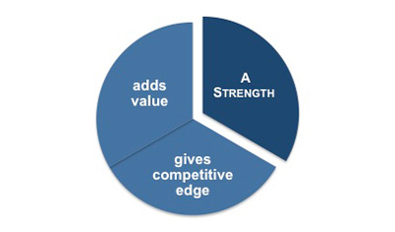
You may want to look at and evaluate your strengths by function, for example marketing, finance, production, and support. Looking at things in this way can make it easier to identify the positive attributes within each function.
However you judge the responses to these questions it must be from the perspective of your operating environment and not from an internal aspect. For example, if 'guaranteed next day delivery' is the norm within your industry then this cannot really be considered a strength because your customers would expect it. On the other hand, if 'guaranteed next day delivery' is not normal in your industry then it could legitimately be classified as a strength.
Weaknesses:
These are the characteristics of your product or service that are detrimental to growth. Weaknesses are those things that detract from the value of your offering or place you at a disadvantage when compared with your competitors.
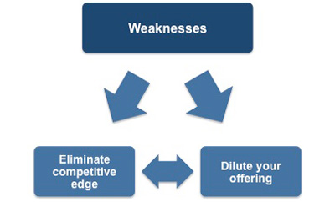
An obvious weakness would be an unsuitable location for your organization. For example,
You are located in the north of the country but 85% of your customers are in the south. This means that not only are your distribution costs significantly higher than some of your competitors but you are unable to offer guaranteed next day delivery in line with your competition.
Factors that are identified as weaknesses can often be remedied with suitable investment or restructuring. In the example above, it might be possible to relocate the business or set up a distribution center in the south of the country, but both of these things would require changes to the way the business currently operates.
While environmental survey helps to identify areas of opportunities and threats in the areas of interest, in order to tap these opportunities, it is necessary to find out whether the firm has the requisite capabilities. For this an internal appraisal is undertaken.
Internal appraisal has three distinct parts:
– Assessment of the strengths and weaknesses of the firm in different functional areas;
– Appraisal of the health of individual businesses;
– Assessment of the firm’s competitive advantage and core competence.
The main task here is to decide the extent of business growth, the firm wants to achieve. The
firm examines the present level of performance, its achievable level over the planning period,and its aspirational level. Balancing the opportunities with the organization’s capabilities andambitions, the firm figures out its growth objective. Usually, firms set objectives in all key areas, like, sales, profits, asset formation, productivity, market share, and corporate image. Objectives have to be stated clear-cut in a measurable time-bound manner. In setting objectives, the firm integrates its growth ambition with the findings it has made with its environment survey and internal appraisal. Product-market scope, growth vector, competitive advantage and synergy are
the constituents of corporate strategy. Findings from the environment survey/opportunity-threat profile, the competitive advantages and synergies enjoyed, and the resources available for growth, are the other major parameters in deciding the basket of businesses and the product market posture. Corporate strategy has to specify through which businesses and through what kind of product-market posture is the growth objective going to be achieved. And it is from this statement that each business of the corporation –existing and new ones – derives its growth targets, direction and priority.
Internal Analysis
Tangible Resources – Assets that can be seen touched or quantified.
- Financial resources (borrowing capacity)
- Physical Resources (facilities, locations)
- Organizational structure (reporting structures)
- Technological (patents)
Intangible Resources
- Human resources (experience, training)
- Resources for innovation (technical employees, facilities)
- Reputation
Brand Equity
- Brand name
- maintaining brand equity (Mercedes example – value/performance and Japanese automakers)

VALUE CHAIN ANALYSIS:

Introduction:
Value chain analysis relies on the basic economic principle of advantage — companies are best served by operating in sectors where they have a relative productive advantage compared to their competitors. Simultaneously, companies should ask themselves where they can deliver the best value to their customers. -

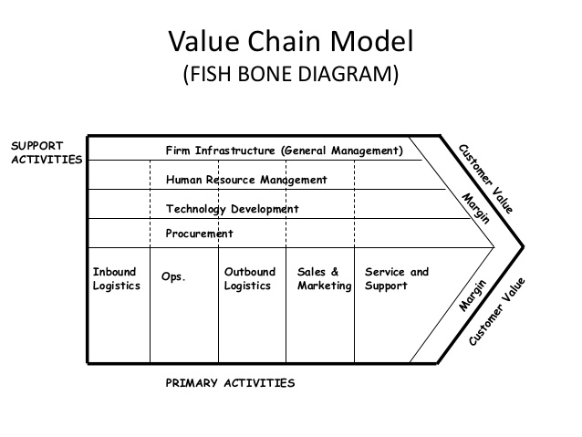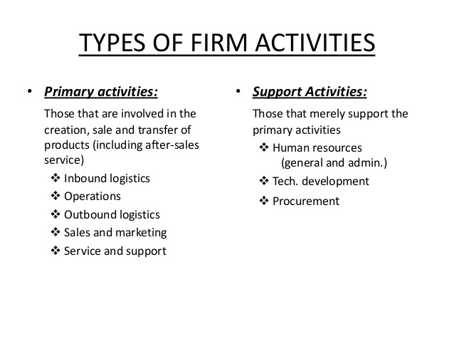
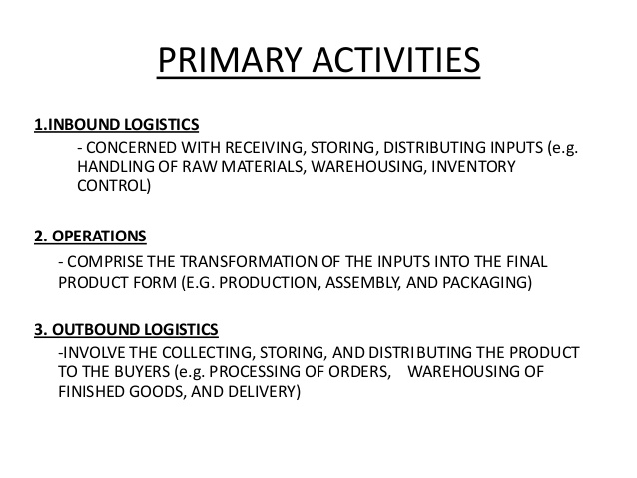

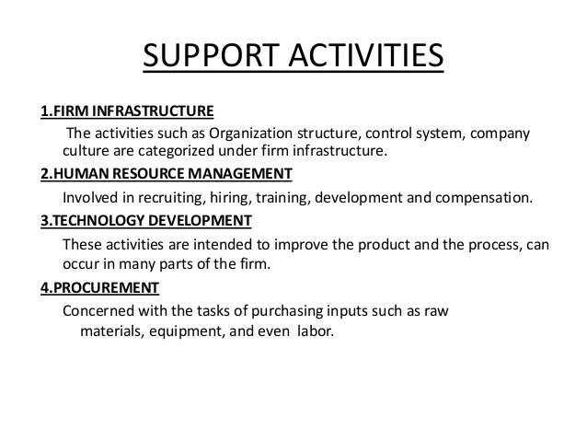

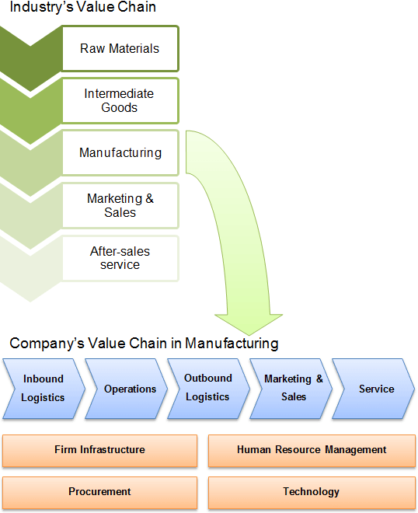
For a company to survive in today’s highly flooded markets a company must, at least
temporarily, achieve a competitive advantage. There are many ways for a firm to achieve this advantage and two generic ones are: price leadership and differentiation. Price leadership is simply when a company keeps prices below those of his competitors. Differentiation occurs when a company creates a distinctive position in the market through product functionality,
service, or quality.
If either of these two management strategies are chosen to be implemented by a company, value chain analysis can help the firm focus its plan and thus achieve a competitive advantage. There are two components of value chain analysis: the industry value chain and the company’s internal value chain. The industry value chain includes all of the value-creating activities within the whole industry, beginning with the basic raw material and finishing with the delivery of the
product. The internal value chain of a company includes all the value creating activities within that specific firm.
The Company’s Internal Value Chain
A firm’s internal value chain includes all the physical and technological activities within the company that add value to the product. The key to evaluating a company’s internal value chain is to understand the activities that give that company a competitive advantage, and then pin point
and exploit those advantages better than other companies in the industry.
This evaluation is done in four steps:
Identify value chain analysis
Look for discrete activities. These create value in different ways. They will include
different costs, different cost drivers, separable assets, and different personnel involved.
For example, contrast product design activities with advertising activities.
Identify structural, procedural, and operational activities. Structural activities
determine the basic economic nature of the company. Procedural activities include all
aspects of the firm's operations and reflect the company's ability to carryout the
processes efficiently and effectively.

Focus on structural and procedural activities. Most companies emphasize operational
activities, but proponents of value chain analysis say that focus is too narrow and only
deals with the short run and will not be able to give the company an overall competitive
advantage.
Determine which activities are strategic
To determine which activities are strategic a company must identify which product
characteristics are valued by existing customers.
A company should then find characteristics that it can exploit, and thereby create value
for future customers. Examples of these characteristics are quality, service, or any
tangible or intangible product features.
Trace costs to activities
The company needs an accounting technique that traces costs to different value chain
activities. This is important for a company to focus on these value-added processes, so
they will be able to manage them more efficiently.
Improve management of value chain activities
To achieve a competitive advantage a company must manage their value chain better
than their competitors. This means reducing a company's total cost while enlarging the
competitive advantage. This does not however mean that all costs have to be reduced, it
means that all costs that do not adversely affect the competitive advantage can and
should be reduced.

The Industry Value Chain
The value chain of an industry starts with the raw material manufacturer and finishes with the
delivery of the final product to the customer. The key to analyzing the industry value chain is to
comprehend and use the advantage of a company’s comparative strength within the industry.
All industries begin with a raw material and end with a sale to a customer. There are many links
within this process. There are upstream links and downstream links. Each separate link stands
for an independent, economically viable segment of the industry. To establish which links in the
industry value chain are separate, assess these two questions:
1. Is there a market for the output of this link in the industry value chain, or can a market
price be determined objectively?
2. Are there any companies that produce and sell only within this link of the chain?

Conclusion
Value chain analysis comes with a few challenges. First, accounting systems are not designed to
assign costs to value-added activities, but when ABC is implemented that problem can be solved.
Second, it can be difficult to find accurate return on sales and return on asset data to determine
the value chain. But, rough estimates still can be used to give some insight into the value chain.
Lastly, not only do estimates make the value chain difficult to determine, but many industries
have very complex value chains. Even though there are some challenges to a value chain
approach it can be a very effective strategic management tool. When competition is fierce, firms
must very precisely manage their activities and costs to continue their competitive advantage.

STRATEGIC ADVANTAGE PROFILE.

Every firm has strategic advantages and disadvantages. For example, large firms have financial strength but they tend to move slowly, compared to smaller firms, and often cannot react to
changes quickly. No firm is equally strong in all its functions. In other words, every firm has strengths as well as weaknesses. Strategists must be aware of the strategic advantages or strengths of the firm to be able to choose the best opportunity for the firm. On the other hand they must regularly analyse their strategic disadvantages or weaknesses in order to face environmental threats effectively. In this session, we shall examine the strategic advantage factors that management analyses and diagnoses to determine the internal strengths and weaknesses with which it must face
the opportunities and threats f rom the environment. In the discussion of these factors, it is not possible to consider in detail, subject matter which are covered by courses on Marketing, Human
These factors will be covered under the following broad headings:
4.2.1 Marketing and Distribution
4.2.2 R & D and Engineering
4.2.3 Production and Operations Management
4.2.4 Corporate Resources and Personnel
4.2.5 Finance and Accounting
Examples:
The Strategist should look to see if the firm is stronger in these factors than its competitors. When a firm is strong in the market, it has a strategic advantage in launching new products or services and increasing market share of present products and services.

Strategic Advantage Factors: Marketing and Distribution
1. Competitive structure and market share: To what extent has the firm established a strong
mark share in the total market or its key sub markets?
2. Efficient and effective market research system.
3. The product-service mix: quality of products and services.
4. Product-service line: completeness of product-service line and product-service mix; phase
of life-cycle the main products and services are in.
5. Strong new product and new-service leadership.
6. Patent protection (or equivalent legal protection for services).
7. Positive feelings about the firm and its products and services on the part of the ultimate
consumer.
8. Efficient and effective packaging of products (or the equivalent for services).
9. Effective pricing strategy for products and services.
10. Efficient and effective sales force: close ties with key customers. How vulnerable are we in
terms of concentrating on sales to a few customers?
11. Effective advertising: Has it established the company's product or brand image to develop
loyal customers?
12. Efficient and effective marketing promotion activities other than advertising.
13. Efficient and effective service after purchase.
14. Efficient and effective channels of distribution and geographic coverage, including
internal efforts.
R & D (Research and Development) and Engineering function can be a strategic advantage
for two reasons:
1. It can lead to new or improved products for marketing
2. It can lead to the development of improved manufacturing or material processes to gain cost
advantages through efficiency.

Strategic Advantage Factors: R&D and Engineering

1. Basic research capabilities within the firm
2. Development capability for product engineering
3. Excellence in product design
4. Excellence in process design and improvements
5. Superior packaging developments being created
6. Improvements in the use of old or new materials
7. Ability to meet design goals and customer requirements
8. Well equipped laboratories and testing facilities
9. Trained and experienced technicians and scientists
10. Work environment suited to creativity and innovation
11. Managers who can explain goals to researchers and research results to higher managers

DIFFERENT APPROACHES TO DEVELOP AN COMPETITIVE ADVANTAGE:

- The first approach is to compete based on existing strengths. This approach is called KFS,abbreviated from Key Success Factors. The firm can gain strategic advantage if it focuse resources on one crucial point.
- The second approach is still based on existing strengths but avoids head-on competition.The firm must look at its own strengths which are different or superior to that of the competition and exploit this relative superiority to the fullest. For example, the strategist
either (a) makes use of the technology, sales network, and so on, of those of its products
which are not directly competing with the products of competitors or (b) makes use differences in the composition of assets. This avoids head-on competition.
- The third approach is used for example to compete directly with a competitor in a
well-established, stagnant industry. Here an unconventional approach may be needed to
upset the key factors for success that the competitor has used to build an advantage. The
starting point is to challenge accepted assumptions about the way business is done and gain
a novel advantage by creating new success factors.
- Finally, a competitive advantage may be obtained by means of innovations which open
new markets or result in new products. This approach avoids head-on competition but
requires the firm to find new and creative strengths. Innovation often involves market
segmentation and finding new ways of satisfying the customer's utility function.
In each of these approaches the principal point is to avoid doing the same thing as the
competition on the same battleground. So the analyst needs to decide which of these
approaches might be pursued to develop a sustainable distinctive competence.

FUNCTIONAL AREA PROFILE & RESOURCE DEVELOPMENT MATRIX

To make a comparative analysis of a firm’s own resource deployment position and focus of
efforts with those of competitors.
• First, technique requires preparation of matrix of functional area with common features.
• Secondly matrix is prepared showing deployment and focus of efforts over a period of
time. 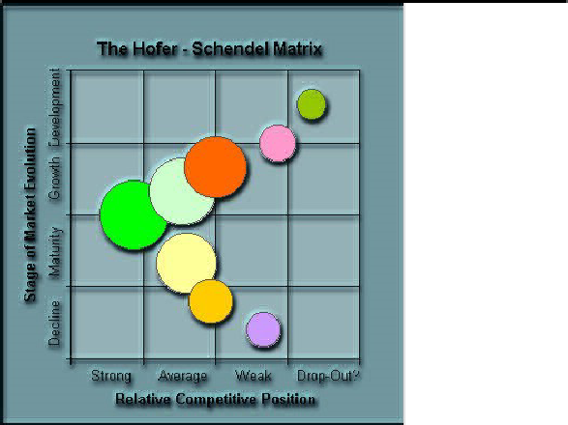

STRATEGIC ADVANTAGE PROFILE:
Strategic advantage profile is known as SAP. It shows strength and weakness of an organization. Preparation of SAP is very similar process to the ETOP. There are generally five functional areas in most of the organizations. These areas:

Ø Production or OperationØ Finance or AccountingØ Research &S Marketing orDistributionØ Human Resource & Corporate Planning

SAP tries to find out the org strengths and weaknesses with relation to some CSF
(CRITICAL SUCCESS FACTOR ANALYSIS)

• Satisfactory performance – required – for organization
– achieve goals
• Identify – tasks & requirements – for success
• CSFs – means to achieve goals
• Sources of CSF - industry, environment & temporal factors
Characteristics of CSF Analysis
–Internal
–External
–Monitor
–Develop
Process of CSF Analysis – Identify
–CSF
–Critical information – internal & external
–Critical assumption set
–Critical decision
Benefits of CSF Analysis
–Results –needs – enterprise – clearly
–Measure success – prioritize goals
–Needs of end users & enterprise are

UNIT – 4
FORMULATION OF STRATEGY

Approaches to Strategy Formation
The initial task in strategic management is typically the compilation and dissemination of a mission statement. This document outlines, in essence, the raison d'etre of an organization.
Additionally, it specifies the scope of activities an organization wishes to undertake, coupled with the markets a firm wishes to serve. Following the devising of a mission statement, a firm would then undertake an environmental scanning within the purview of the statement.
Strategic formation is a combination of three main processes which are as follows:

 Performing a situation analysis, self-evaluation and competitor analysis: both internal and
external; both micro-environmental and macro-environmental.

 Concurrent with this assessment, objectives are set. These objectives should be parallel to a time-line; some are in the short-term and others on the long-term. This involves crafting vision statements (long term view of a possible future), mission statements (the role that the organization gives itself in society), overall corporate objectives (both financial and strategic), strategic business unit objectives (both financial and strategic), and tactical
objectives.

STEPS IN STRATEGY FORMULATION:

Strategy formulation refers to the process of choosing the most appropriate course of action for
the realization of organizational goals and objectives and thereby achieving the organizational vision. The process of strategy formulation basically involves six main steps. Though these steps do not follow a rigid chronological order, however they are very rational and can be easily

followed in this order.

1. Setting Organizations’ objectives - The key component of any strategy statement is to set the long-term objectives of the organization. It is known that strategy is generally a medium for realization of organizational objectives. Objectives stress the state of being there whereas Strategy stresses upon the process of reaching there. Strategy includes both the fixation of objectives as well the medium to be used to realize those objectives. Thus, strategy is a wider term which believes in the manner of deployment of resources so as to achieve the objectives.
While fixing the organizational objectives, it is essential that the factors which influence the selection of objectives must be analyzed before the selection of objectives. Once the objectives and the factors influencing strategic decisions have been determined, it is easy to take strategic
decisions.
2. Evaluating the Organizational Environment - The next step is to evaluate the general economic and industrial environment in which the organization operates. This includes a review of the organizations competitive position. It is essential to conduct a qualitative and quantitative review of an organizations existing product line. The purpose of such a review is to make sure that the factors important for competitive success in the market can be discovered so that the management can identify their own strengths and weaknesses as well as their competitors’
strengths and weaknesses. After identifying its strengths and weaknesses, an organization must keep a track of competitors’ moves and actions so as to discover probable opportunities of threats to its market or supply sources.
3. Setting Quantitative Targets - In this step, an organization must practically fix the
quantitative target values for some of the organizational objectives. The idea behind this is to
compare with long term customers, so as to evaluate the contribution that might be made by
various product zones or operating departments.
4. Aiming in context with the divisional plans - In this step, the contributions made by each department or division or product category within the organization is identified and accordingly strategic planning is done for each sub-unit. This requires a careful analysis of macroeconomic trends.
5. Performance Analysis - Performance analysis includes discovering and analyzing the gap between the planned or desired performance. A critical evaluation of the
organizations past performance, present condition and the desired future conditions must be done by the organization. This critical evaluation identifies the degree of gap that persists between the actual reality and the long-term aspirations of the organization. An attempt is made by the organization to estimate its probable future condition if the current trends persist.
6. Choice of Strategy - This is the ultimate step in Strategy Formulation. The best course of action is actually chosen after considering organizational goals, organizational strengths, potential and limitations as well as the external opportunities.

DIVERSIFICATION
Diversification is a form of corporate strategy for a company. It seeks to increase profitability through greater sales volume obtained from new products and new markets. Diversification can occur either at the business unit level or at the corporate level. At the business unit level, it is most likely to expand into a new segment of an industry that the business is already in. At the corporate level, it is generally very interesting entering a promising business outside of the scope of the existing business unit.
Diversification is part of the four main growth strategies defined by the Product/Market Ansoff matrix:
Ansoff pointed out that a diversification strategy stands apart from the other three strategies. The first three strategies are usually pursued with the same technical, financial, and merchandising resources used for the original product line, whereas diversification usually requires a company to acquire new skills, new techniques and new facilities.

RETRENCHMENT:

Retrenchment is a corporate level strategy that aims to reduce the size or diversity of an
organization. Retrenchment is also reduction in expenditure to become financially stable.
Retrenchment strategy is a strategy used by corporate in order to reduce the diversity or to cut
the overall size of the operations of the company. This strategy is often used to cut down
expenses with the goal of becoming more financially stable business. Typically the strategy
involves withdrawing from certain markets or the discontinuation of selling certain products or
services in order to make a beneficial turn around. Retirement is one of the retrenchment
strategies. It is a point where a person stops employment completely. A person may also semi
retire by reducing work hours. Many people choose to retire when they are eligible for private or
public pension benefits, although some are forced to retire when physical conditions do not allow
them to work anymore. Retrenchment is something akin to downsizing. When a company or
government goes through retrenchment, it reduces outgoing money or expenditures or redirects
focus in an attempt to become more financially solvent. Many companies that are being
pressured by stockholders or have had flagging profit reports may resort to retrenchment to shore
up their operations and make them more profitable. Although retrenchment is most often used in
countries throughout the world to refer to layoffs, it can also label the more general tactic of
cutting back and downsizing. Companies can employ this tactic in two different ways. One way
is to slash expenditures by laying off employees, closing superfluous offices or branches,
reducing benefits such as medical coverage or retirement plans, freezing hiring or salaries, or
even cutting salaries. There are numerous other ways in which a company can employ
retrenchment. These can be non-employee related, such as reducing the quality of the materials
used in a product, streamlining the process in which a product is manufactured or produced, or
moving headquarters to a location where operating costs are lower. The second way in which a
company may practice retrenchment is to downsize in one market that is proving unprofitable
and build up the company in a more profitable market. If one market has become obsolete due to
modernization or technology, then a company may decide to change with the times to remain
profitable.

Retrenchment Strategy
A strategy used by corporations to reduce the diversity or the overall size of the operations of the company. This strategy is often used in order to cut expenses with the goal of becoming a more financial stable business. Typically the strategy involves withdrawing from certain markets or the discontinuation of selling certain products or service in order to make a beneficial turnaround.
Different Types of Retrenchment Strategies of Business are given below:
Retrenchment can be divided into the following categories:
1. Turn around Strategies
Turnaround strategy means backing out, withdrawing or retreating from a decision wrongly taken earlier in order to reverse the process of decline. There are certain conditions or indicators which point out that a turnaround is needed if the organization has to survive. These danger signs
are as follows:
a) Persistent negative cash flow
b) Continuous losses
c) Declining market share
d) Deterioration in physical facilities
2. Divestment Strategies
Divestment strategy involves the sale or liquidation of a portion of business, or a major division,profit centre or SBU. Divestment is usually a restructuring plan and is adopted when a turnaround has been attempted but has proved to be unsuccessful or it was ignored. A divestment
strategy may be adopted due to the following reasons:
a) A business cannot be integrated within the company.
b) Persistent negative cash flows from a particular business create financial problems for the
whole company.
c) Firm is unable to face competition
3. Liquidation Strategies
Liquidation strategy means closing down the entire firm and selling its assets. It is considered the most extreme and the last resort because it leads to serious consequences such as loss of employment for employees, termination of opportunities where a firm could pursue any future activities, and the stigma of failure. Generally it is seen that small-scale units, proprietorship firms, and partnership, liquidate frequently but companies rarely liquidate. The company management, government, banks and financial institutions, trade unions, suppliers and creditors, and other agencies do not generally prefer liquidation.
Liquidation strategy may be unpleasant as a strategic alternative but when a "dead business is worth more than alive", it is a good proposition. For instance, the real estate owned by a firm may fetch it more money than the actual returns of doing business.
Liquidation strategy may be difficult as buyers for the business may be difficult to find.
Moreover, the firm cannot expect adequate compensation as most assets, being unusable, are considered as scrap.
Reasons for Liquidation include:
(i) Business becoming unprofitable
(ii) Obsolescence of product/process
(iii) High competition

BCG MODEL
Boston Consulting Group (BCG) Matrix is a four celled matrix (a 2 * 2 matrix) developed by BCG, USA. It is the most renowned corporate portfolio analysis tool. It provides a graphic representation for an organization to examine different businesses in it’s portfolio on the basis of their related market share and industry growth rates. It is a two dimensional analysis on management of SBU’s (Strategic Business Units). In other words, it is a comparative analysis of business potential and the evaluation of environment.
According to this matrix, business could be classified as high or low according to their industry growth rate and relative market share.
Relative Market Share = SBU Sales this year leading competitors sales this year.
Market Growth Rate = Industry sales this year - Industry Sales last year.
The analysis requires that both measures be calculated for each SBU. The dimension of business strength, relative market share, will measure comparative advantage indicated by market dominance. The key theory underlying this is existence of an experience curve and that market share is achieved due to overall cost leadership.
BCG matrix has four cells, with the horizontal axis representing relative market share and the vertical axis denoting market growth rate. The mid-point of relative market share is set at 1.0. if all the SBU’s are in same industry, the average growth rate of the industry is used. While, if all the SBU’s are located in different industries, then the mid-point is set at the growth rate for the economy.
Resources are allocated to the business units according to their situation on the grid. The four cells of this matrix have been called as stars, cash cows, question marks and dogs. Each of these cells represents a particular type of business.
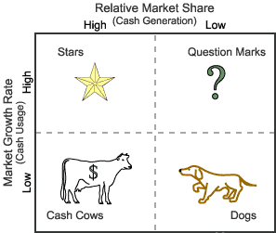
10 x 1 x 0.1 x
Figure: BCG Matrix
- Stars- Stars represent business units having large market share in a fast growing industry. They may generate cash but because of fast growing market, stars require huge investments to maintain their lead. Net cash flow is usually modest. SBU’s located in this cell are attractive as they are located in a robust industry and these business units are highly competitive in the industry. If successful, a star will become a cash cow when the industry matures.
- Cash Cows- Cash Cows represents business units having a large market share in a mature, slow growing industry. Cash cows require little investment and generate cash that can be utilized for investment in other business units. These SBU’s are the corporation’s key source of cash, and are specifically the core business. They are the base of an organization. These businesses usually follow stability strategies. When cash cows loose their appeal and move towards deterioration, then a retrenchment policy may be pursued.
- Question Marks- Question marks represent business units having low relative market share and located in a high growth industry. They require huge amount of cash to maintain or gain market share. They require attention to determine if the venture can be viable. Question marks are generally new goods and services which have a good commercial prospective. There is no specific strategy which can be adopted. If the firm thinks it has dominant market share, then it can adopt expansion strategy, else retrenchment strategy can be adopted. Most businesses start as question marks as the company tries to enter a high growth market in which there is already a market-share. If ignored, then question marks may become dogs, while if huge investment is made, then they have potential of becoming stars.
- Dogs- Dogs represent businesses having weak market shares in low-growth markets. They neither generate cash nor require huge amount of cash. Due to low market share, these business units face cost disadvantages. Generally retrenchment strategies are adopted because these firms can gain market share only at the expense of competitor’s/rival firms. These business firms have weak market share because of high costs, poor quality, ineffective marketing, etc. Unless a dog has some other strategic aim, it should be liquidated if there is fewer prospects for it to gain market share. Number of dogs should be avoided and minimized in an organization.

Limitations of BCG Matrix
The BCG Matrix produces a framework for allocating resources among different business units and makes it possible to compare many business units at a glance. But BCG Matrix is not free from limitations, such as-
- BCG matrix classifies businesses as low and high, but generally businesses can be medium also. Thus, the true nature of business may not be reflected.
- Market is not clearly defined in this model.
- High market share does not always leads to high profits. There are high costs also involved with high market share.
- Growth rate and relative market share are not the only indicators of profitability. This model ignores and overlooks other indicators of profitability.
- At times, dogs may help other businesses in gaining competitive advantage. They can earn even more than cash cows sometimes.
- This four-celled approach is considered as to be too simplistic.

Making good strategic choices – Directional Policy Matrix

The essence of strategy is that it is a choice between two or more good options.
In developing a marketing strategy the choice to be made is of which segments of the market you should develop tactics to pursue.
The Directional Policy Matrix (DPM) is a tool for helping you determine what your preferred segments are. In completing a DPM you understand what you should invest in and the direction your organisation should take. The directional policy matrix helps you determine whether decisions made in the day-to-day running of the organisation are in it’s best interest.
The Directional Policy Matrix measures the attractiveness of a segment and the capability of the organisation to support that segment.

Segment Attractiveness of a Market
Evaluating the attractiveness of a segment should include but not be limited to, these variables:
- Size of the segment (number of customers, units or $ sales)
- Growth rate of the segment (a very important variable)
- Profit margins of the segment to the sales organisation
- Ongoing purchasing power of the segment
- Attainable market share given promotional budget, fragmentation of the market and competitors’ promotional expenditures
- Required market share to break even.

Capability of the organization
Evaluating the capability of the organisation to meet the needs of the segments should include, but not be limited to, these variables analysed against the competition:
- Competitive capability of the organisation against the marketing mix (product/service, place, price and promotion)
- Access to distribution channels
- Capital and human resource investment required to serve the segment
- Brand association of the organisation in the eyes of the segment
- Current market share/likely future market share.

Scoring the Directional Policy Matrix:
To score the DPM you need to know the goal of your marketing strategy. This may be, but not limited to:
- Profit lift
- Market share lift
- Value of the organisation if it were for sale.
Complete scoring the directional policy matrix in four steps:
- Weight the relative importance of each factor of attractiveness and capability in terms of its contribution to the goal of the marketing strategy out of 1.
- Allocate the respective weight of a total score of 48 points to each factor. e.g. if the weighting for a factor was 0.2 then the total points available for that factor is 0.2X48=10 (rounded up)
- Score each segment relative to the other segments in how much each segment meets the criteria of the factor. e.g. For the attractiveness factor ‘Size of segment’, in the example Table 1, score the largest segment 10 and the smallest segment 1.
- Plot the resultant score in excel and create a bubble chart graph where the size of the bubble represents the size of the segment for greater visual clarity when it comes to interpreting the analysis.
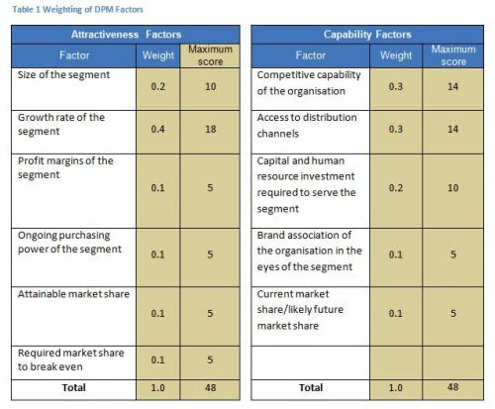
Below is an example chart for an organisation selling services.
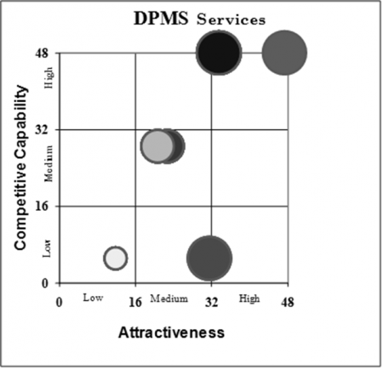

Interpreting the Directional Policy Matrix
The directional policy matrix suggests tactics for each of nine sectors, as shown in the figure below.
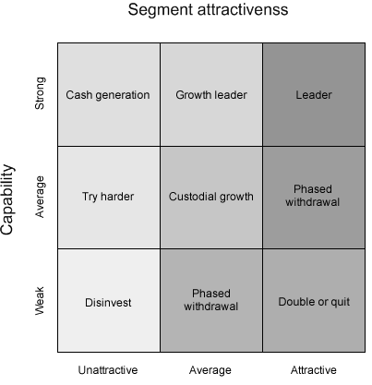
The tactics for each sector descriptor are:
- Leader – Focus your resources on segments in this sector.
- Growth leader – Grow by focusing just enough resources here.
- Cash Generator – Milk segments in this sector for expansion elsewhere.
- Phased withdrawal – Move cash to segments with greater potential.
- Custodial – Do not commit any more resources to segments in this sector.
- Try harder –Determine if there are ways in which you can build your capability for segments in this sector for low levels of cash.
- Double or quit – Invest in your capability or get out of segments in this sector.
- Divest – Liquidate or move assets used in segments in this sector as fast as you can.

